**Leader Overview**

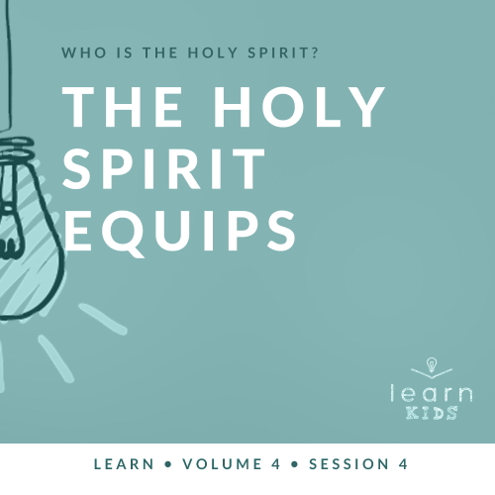

**Volume Overview**

**Who is the Holy Spirit?**

*In His most famous sermon (*[*Matthew 5–7*](https://ref.ly/logosref/Bible.Mt5-7)*), Jesus taught us to love our enemies, give to the needy, and put God’s kingdom first in our life. These high expectations don’t take us long to recognize a problem. We simply can’t do this on our own. So, why did Jesus command us to live a life He knows full well we cannot live on our own? The key is that Jesus never asked us to live the Christian life on our own. In fact, Jesus explained there is a gift that is indispensable for every Christian: the Holy Spirit. Jesus as God in the flesh is a wonderful gift, and God living inside us is amazing too! God living within us can empower us, help us grow, and equip us in a unique way that God among us could not*.

**Session Overview**

**The Holy Spirit Equips**

*The Holy Spirit equips us so that we can help others. In our Bible story today, the Holy Spirit spoke to Philip and guided him to talk with an Ethiopian man. Through Philip’s obedience, the gospel message was spread to a different country. The Holy Spirit equipped Philip with everything he needed to fulfill the task he was called to do*.

**Bible Lesson**

Philip Meets the Ethiopian

[Acts 8:26–40](https://ref.ly/logosref/Bible.Ac8.26-40)

**Faith Fact**

The Holy Spirit teaches me.

**Faith Verse**

[Galatians 5:22–23](https://ref.ly/logosref/Bible.Ga5.22-23) (NLT)

The Holy Spirit produces this kind of fruit in our lives: love, joy, peace, patience, kindness, goodness, faithfulness, gentleness, and self-control.

**Preparing for the Session**

**Leader Preparation Time: 20–25 Minutes**

|  |
| --- |
| ***You Will Need***  ***Large Group***   * *Bible* * *Worship songs (Song suggestions: “Holy Spirit” by Kari Jobe; “Set a Fire” by Jesus Culture; “Come Holy Spirit” by Vertical Worship; “Zeal” by The Belonging Co)* * *For groups not using a phone or tablet only, add:*   *• Projector or TV*  *• Laptop*  *•* ***Faith Fact Slide***  *•* ***Faith Verse Video*** *or* ***Slide***  ***• Bible Lesson Video***  ***• Teaching Point Slides 1–3***  *• Flashlight*  *• Toolbox with tools*  ***Small Group***   * *Bibles for kids in your group to share* * ***Small Group Faith Verse Review****, one set per group* * *Scissors* * *Paper* * *Pens* * *Markers* * *Sticky notes* * ***Small Group Activity Page****, one per kid* * *Pencils or pens, one per kid* * *Crayons*   *To access session content and videos from a computer, visit:* [*BibleEngagementProject.com/downloads*](https://bibleengagementproject.com/downloads) |
| ***Getting Ready***  ***Large Group***   * *Download videos and slides if needed.* * *Select worship song(s) and have them ready to play.* * *Read the Bible Lesson Scripture to prepare for teaching time.*   ***Small Group***   * *Print the* ***Small Group Faith Verse Review****, one set per group.* * *Cut apart the slips.* * *Print copies of the* ***Small Group Activity Page****, one per kid.*   ***First time leading* Learn *for Kids? Check out the*** [***Facilitator Guide***](https://0b769b0ed3569ef9d18b-f88d8272f61086866d50d048b43ef630.ssl.cf2.rackcdn.com/sites/biblengagementproject/Listen_Facilitator_Guide.pdf)***.*** |

**Large Group**

**30 Minutes**

*See what’s needed at the beginning of the session.*

**Introduction**

Welcome! I’m so glad you’re here because we’re learning about the Holy Spirit again today. We’ve been answering the big question: Who is the Holy Spirit? What are some of the things you’ve learned about the Holy Spirit so far? *(Allow responses.)* Some of the things I remember are that the Holy Spirit is God, He gives us power, and He helps us.

**Faith Fact**

We’re finishing our study on the Holy Spirit by learning how He equips and teaches us. He is both the Helper and our teacher. We’ll find out more about that during our time together, but our Faith Fact tells us that. **The Holy Spirit teaches me**.

• *Show the* ***Faith Fact Slide***.

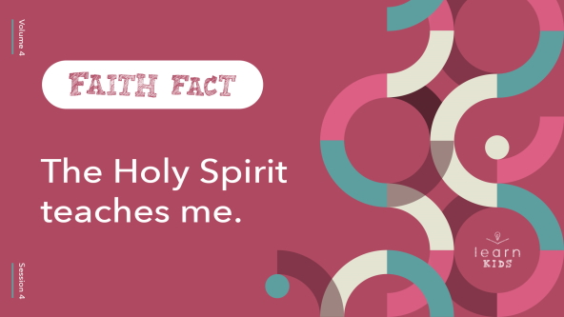

Can you say that with me? *(Group response)* **The Holy Spirit teaches me**. Great job! No matter how old you are, there is always something you’ll need the Holy Spirit to teach you.

**Game**

**Which Tool Are You?**

Have you ever helped one of your parents with a fix-it project at home? *(Group response)* Different tools are needed to fix different things. The tools do different jobs. In a similar way, the Holy Spirit equips each of us with the “tools” or gifts we need to do what God has called us to do. The gifts He gives to you will most likely be different from what He gives to others.

For this game, you’re going to choose a different tool to be for each round. Here are the options:

• *Hammer =* *Make a fist with one hand and pound it on the open palm of the other hand*.

• *Saw = Make a sawing motion with your arm*.

• *Drill =* *Point straight ahead with the index finger of one hand like you’re pointing a drill toward the wall. Make a buzzing sound with your mouth*.

Let’s practice these. Stand up and do these actions with me.

• *Call out the hammer, saw, and drill actions for kids to follow*.

• *Go over the actions a few times to make sure the kids know them well*.

During each round of the game, the leader will turn his back to us. When I say, “Ready,” you’ll choose a tool motion to do. When I say, “Set,” you’ll freeze in place using the tool you’ve chosen. When everyone is ready, I’ll say, “Go.” Then, the leader will choose a tool action to do and quickly turn around to face us.

Here’s the catch. If you’re doing the same tool action as the leader or you didn’t choose any tool at all, you’re out of the game and you’ll sit down. Let’s play.

• *Choose a leader to come to the front and turn away from the group*.

• *Keep playing until most or all of the kids have been eliminated*.

Great job, everyone! You may not have always chosen the right tool to stay in the game. Thankfully, it’s different for the Holy Spirit. He always equips us with the right tools we need to do what God has called us to do. He teaches us as we grow.

**Worship**

How do you think the Holy Spirit would teach us to worship? *(Allow responses.)* I believe the Holy Spirit wants us to worship God with everything we have. Are you ready to do that today? Let’s sing our worship to God now.

• *Lead the kids in singing one or two praise songs. See suggestions at the beginning of the session*.

**Bible Lesson**

The Holy Spirit is the best teacher we could ask for. He’s always there to help you every day, and He never goes on vacation. We can learn something new from the Holy Spirit right now. As we pray, let’s ask the Holy Spirit to teach us something new during our Bible Lesson.

**Prayer**

|  |
| --- |
| *God, thank You that the Holy Spirit is the best Teacher. He is here to teach to us all the time. Help us to learn something new from You right now. Amen.* |

**Video Intro**

Just before we look at the Bible story, let’s watch this video.

• *Play* ***Bible Lesson Video***.

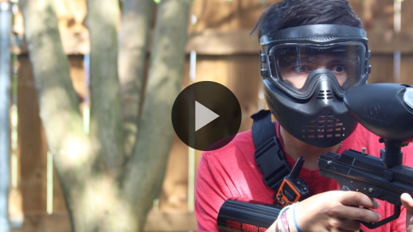

**Bible Story**

**Philip Meets the Ethiopian**

That’s such a fun lead-in to our Bible story today! Let’s see what God’s Word shows us about how the Holy Spirit equips and teaches us. Have you ever gone somewhere new because a friend took you there? *(Group response)*

In today’s Bible story, that’s what happened to Philip. Instead of a friend, it was an angel of the Lord who told Philip to go somewhere. Do you think Philip went? *(Group response)* Let’s find out what Philip chose to do. If you want to follow along, open your Bible to [Acts 8:26–40](https://ref.ly/logosref/Bible.Ac8.26-40).

• *Read the Bible story aloud to the group*.

• *In order to keep Large Group time moving along, we don’t recommend having the kids read*.

• *Optional: Remind the kids to mark this place with their Bible Bookmark, so they can read it on their own at home*.

**Teaching Time**

|  |
| --- |
| ***You Will Need***   * *Flashlight* * *Toolbox with tools*   *No prep needed for this activity.* |

Philip followed the directions the angel gave him. He ended up on a road where someone needed his help. Because Philip was listening, teachable, and followed directions, the Ethiopian man believed in Jesus and was baptized right away. Let’s find out what we can learn from this.

**1. The Holy Spirit speaks to me**.

• *Show the* ***Teaching Point 1 Slide***.

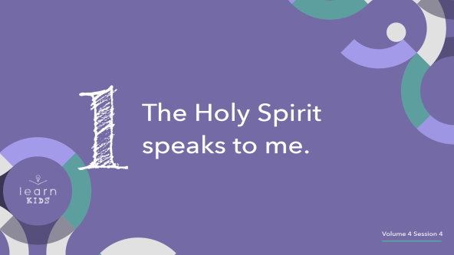

The Holy Spirit spoke to Philip that day, and He wants to speak to you, too. Now, it doesn’t say that the Holy Spirit appeared to Philip in a great light or that he heard a loud voice. The Bible simply says the Holy Spirit told Philip where to walk. No one else probably heard what the Holy Spirit said, but they didn’t need to.

The Holy Spirit could speak directly to Philip because he was a believer and follower of Jesus. That means the Holy Spirit lived inside Philip. Remember the Holy Spirit lives inside you too if you’re a believer and follower of Jesus.

When your parents or friends say something to you, how do you hear them? *(Allow responses.)* You hear them with your ears, of course, but that’s not typically how you would hear the Holy Spirit when He speaks to you. The Holy Spirit often speaks to our mind instead of our ears.

How do you know it’s the Holy Spirit speaking to you? That’s something you have to ask Him to teach you. We must learn to listen for His voice. What He tells us to do will often sound different from what we might think to do on our own. But it will always line up with the Bible. I’ll tell you a little more about that in a little bit.

**2. The Holy Spirit guides us**.

• *Show the* ***Teaching Point 2 Slide***.

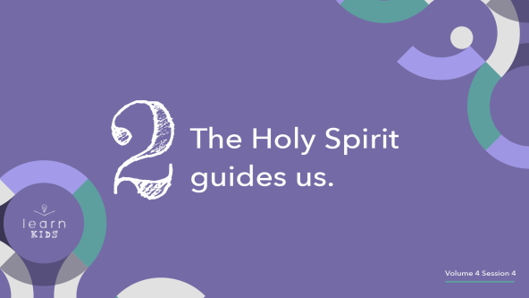

The Holy Spirit often speaks to us and teaches us by guiding us. When the Holy Spirit lives in us, we can allow Him to guide our life. Philip modeled this in our Bible story when the Holy Spirit led him to the Ethiopian man’s carriage. In our life, we must allow the Holy Spirit to guide us because His plans for our life are best.

The Holy Spirit doesn’t always give us the whole picture when He speaks to us. Think about this story of Philip and the Ethiopian. Did the angel tell Philip why he needed to go to the desert road? *(Group response)* No, the angel just told him to go. Did the Holy Spirit tell Philip why he needed to go walk beside the Ethiopian’s carriage? *(Group response)* No, the Spirit just told him to do it.

It’s like the difference between a completely lit up room and a dark room.

• *Make sure all the lights are on*.

• *Have someone turn off all the lights while you speak*.

• *Turn on a flashlight and begin to walk around the room*.

In total darkness, the flashlight gives just enough light to see what’s ahead and guide me where I need to go. That’s how the Holy Spirit sometimes works.

I’m sure it was scary for Philip to follow those instructions without knowing why he was going, but Philip obeyed anyway. What happened because of Philip’s obedience? *(Allow responses.)*

Let’s imagine what might have happened if Philip had been scared or stubborn and chosen not to go. How do you think things would have turned out? *(Allow responses.)* Philip could have missed the opportunity to share Jesus with someone who needed to hear.

When the Holy Spirit guides us, it can feel like a little nudge or a strong thought that doesn’t go away. Maybe the nudge is to go talk to someone who is all alone. Maybe it’s a feeling that you need to share Jesus with a friend who isn’t a Christian. Listen to those nudges and follow them just like Philip followed the direction of the angel and the Holy Spirit. Then, watch how God uses you through your obedience to His Holy Spirit.

• *Have someone turn the lights back on*.

**3. The Holy Spirit equips me to serve**.

• *Show the* ***Teaching Point 3 Slide***.

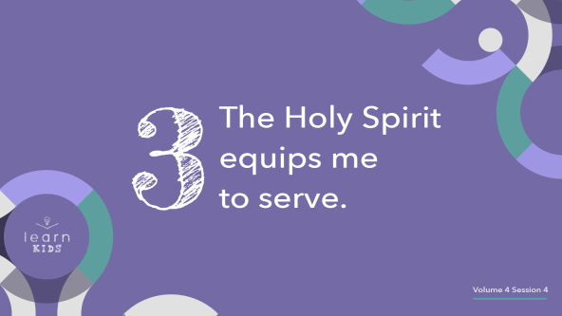

On top of speaking to us and guiding our life, the Holy Spirit equips us. What does that word *equip* mean? *(Allow responses.)* The Holy Spirit gives us what we need to serve God. He can give people special gifts to help them serve God more effectively.

Another way of looking at it is that the Holy Spirit gives us the right “tools” to get the job done.

• *Pull out a toolbox. Open it up and take out different tools while you speak*.

Is there one universal tool that can get any job done? *(Group response)* Some people might argue that duct tape can do anything, but that’s not really true. We couldn’t build a house with just duct tape. We need a variety of tools to perform different tasks to get each job done. Let’s see if you can guess what each of these tools does and what you could use them to fix.

• *Hold up a few different tools one at a time and have kids guess what each one is and does*.

Great job, everyone! You really know your tools. Similarly, the “tools” or gifts the Holy Spirit give us are designed to build up the Church and reach people who don’t know Jesus. When the Holy Spirit gives us directions to do something, He will also equip us with the gifts we need to accomplish it.

**Prayer and Response**

*Consider playing a worship song softly in the background while kids pray*.

You might be wondering about the gifts or talents you have. Maybe you aren’t sure what they are, or you might feel like they aren’t good enough. You might look at your friends’ talents and think they have more to offer than you do.

First, never compare your gifts and talents to what God has chosen to give to others. Remember, the Holy Spirit will equip you with the tools you need to do what God has called you to do. You don’t need what your friend has. You need the Holy Spirit to equip you for what God wants you to do.

Let’s take a few minutes to offer our time and energy to the Holy Spirit and ask Him to give us gifts to do His work. Let’s open our hands as we pray. *(Group response)* Be open and ready to hear His voice, follow His guidance, and allow Him to equip you with new tools to serve God even better. Let’s pray.

**Prayer**

• *Optional: Have the kids repeat phrases of the prayer after you*.

|  |
| --- |
| Father God, equip us through the Holy Spirit to do Your work. We want to do whatever it is that You have for us, so help us to know how to do that. Give us the power we need. Teach us what we need to learn. Show us how to be like You so that we can be a light for others. Thank You. Amen. |

**Faith Verse**

One of the most important things the Holy Spirit wants to equip every one of us with is the fruit of the Spirit. Let’s say our Faith Verse together.

• *Play* ***Faith Verse Video***.

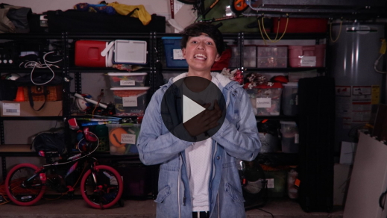

[Galatians 5:22–23](https://ref.ly/logosref/Bible.Ga5.22-23) (NLT)

The Holy Spirit produces this kind of fruit in our lives: love, joy, peace, patience, kindness, goodness, faithfulness, gentleness, and self-control.

The Holy Spirit will continue to grow His fruit in our life and teach us new things as we grow in Him. Who still needs to grow in the fruit of the Spirit? *(Group response)* Everyone’s hand should be raised because we all need to continue learning from the Holy Spirt, our Teacher.

**Faith Fact**

That reminds me of today’s Faith Fact. **The Holy Spirit teaches me**.

• *Show the* ***Faith Fact Slide***.



Say it with me. **The Holy Spirit teaches me**. The Holy Spirit won’t force you to learn from Him or listen to Him. You have to choose to allow Him to speak to you, guide you, and equip you.

• *Dismiss kids to Small Group time or to go home if your group time ends here*.

**Small Group**

**30 Minutes**

*This section can be done in conjunction with the large group or on its own if you do small groups with your kids. During Small Group time, the goal is to connect the kids with the Word of God and to each other. All activities are led by the small group leader.*

**Group Connection**

**Teach Us!**

Do you have any talents? *(Allow responses.)* Everyone does. The Holy Spirit can teach us how to use the talents we’ve been given for God. He can even give us special gifts that we’ve never had before. Do you think you can teach us something by using one of your talents? *(Allow responses.)*

Let’s try. Everyone is going to have the opportunity to show and teach us something they can do. Maybe it’s a song or Bible verse you know. Maybe it’s how to draw something or tell a joke. While you’re thinking, I’ll go first.

• *The leader should quickly teach the kids something from one of their talents*.

• *Let kids take turns teaching others in the group. Don’t force any of the kids to share if they don’t want to. Encourage the kids to be supportive of each other and open to learning something new*.

Those were all amazing things you taught us today. I’m so glad the Holy Spirit equips each of us with the unique gifts and talents we need.

**Learn about It**

|  |
| --- |
| ***You Will Need***  *• Bibles for kids in your group to share*  *No prep needed for this activity.* |

**Scripture Search:** [**John 14:12–14**](https://ref.ly/logosref/Bible.Jn14.12-14)**;** [**Romans 8:14–17**](https://ref.ly/logosref/Bible.Ro8.14-17)**;** [**Ephesians 2:8–9**](https://ref.ly/logosref/Bible.Eph2.8-9)**;** [**1 Timothy 2:3–6**](https://ref.ly/logosref/Bible.1Ti2.3-6)

Let’s dig deeper into God’s Word and see what else He has to say about the Holy Spirit. As we find and read each of these verses, let’s consider: What does this Scripture mean for our life today?

• *Give each kid a Bible and search for one or more of the Scriptures as a group together (as time allows). When everyone has found the Scripture, have one of the kids read it. Then, answer the questions about it*.

• *Pair kids who need additional help with older kids or start simple and look up the session’s Bible story Scripture:* [*Acts 8:26–40*](https://ref.ly/logosref/Bible.Ac8.26-40)*. Kids will get better finding Scriptures the more they practice*.

• *Optional: Make this a competition to see who can find the Scripture first*.

**Bible Reading Tip**

One of the ways the Holy Spirit teaches us and equips us is through God’s Word. We can hear the Holy Spirit speak to us when we’re reading our Bible. He may point out a specific verse to us or speak something entirely new to us.

**Challenge**

In order to hear from the Holy Spirit through God’s Word, we need to read the Bible regularly. Set a goal to spend five minutes each day reading the Bible. When you sense the Holy Spirit is teaching you something, take a moment to write it down in a journal or on a sticky note. Place it somewhere you’ll see it every day. The more you listen for the Holy Spirit, the more you’ll hear Him speak to you.

**Faith Fact**

All of our Bible reading is a reminder to me of our Faith Fact. Say it with me: **The Holy Spirit teaches me**.

**Group Discussion**

*Feel free to use all or just a few questions as a jumping-off place for good discussion. Questions marked with * are designed for more conversation. Adjust the questions based on the age or maturity of your group. Typically, older kids will be able to dive a little deeper than younger ones*.

**Questions**

• *If small group activities are not immediately following large group time, you may want to read the Bible story passage before this discussion*.

Where did the angel of the Lord lead Philip?

Who did Philip meet on the road?

Who told Philip to go up to the carriage and walk next to it?

What happened after they stopped the carriage?

* What is one way the Holy Spirit can speak to you?

* What is something you need the Holy Spirit’s guidance for?

* What gifts or talents do you have?

* What is a talent you would be interested in growing or learning about more?

**Prayer Requests**

*Finish group discussion by sharing prayer requests and praise reports. Keep track of your small group’s prayer requests and review them each time you meet*.

**Prayer**

*Have kids pray for each other’s prayer requests*.

**Faith Verse Review**

|  |
| --- |
| ***You Will Need***   * ***Small Group Faith Verse Review****, one set per group* * *Scissors* * *Paper* * *Pens* * *Markers* * *Sticky notes*   ***Getting Ready***   * *Print the* ***Small Group Faith Verse Review****, one set per group.* * *Cut apart the slips.* |

Our Faith Verse is [Galatians 5:22–23](https://ref.ly/logosref/Bible.Ga5.22-23). It reminds us of so many things we need to learn from the Holy Spirit. He wants to grow many things in our life each day. Let’s watch the Faith Verse video and do the actions for the verse together.

[Galatians 5:22–23](https://ref.ly/logosref/Bible.Ga5.22-23) (NLT)

The Holy Spirit produces this kind of fruit in our lives: love, joy, peace, patience, kindness, goodness, faithfulness, gentleness, and self-control.

• *Show* ***Faith Verse Video***.



**Faith Verse Fun**

**Teach the Verse!**

We’ll pair up for this game. Since we’re talking about teaching today, each pair work together to come up with a creative way to teach the verse to the rest of us. That’s right, you’re going to teach today. You can use some of the supplies I have provided or do something on your own. Get as creative as you like: sing, do new motions, use the Faith Verse cards, draw pictures, or whatever you like.

• *Allow the kids to form pairs. Make sure at least one kid in each pair knows the Faith Verse*.

• *Allow the pairs to use any of the supplies you have provided to come up with a creative way to teach the Faith Verse to the group. Encourage them to be as creative as possible*.

Now, that you’ve had time to practice, lead the group in your new idea.

• *Let the pairs of kids teach the Faith Verse*.

Great job, everyone! You didn’t have much time to prepare, but you did great.

**Activity Page**

**Spot the Difference**

|  |
| --- |
| ***You Will Need***   * ***Small Group Activity Page****, one per kid* * *Pencils or pens, one per kid* * *Crayons*   ***Getting Ready***   * *Print copies of the* ***Small Group Activity Page****, one per kid.* |

Philip shows us how to listen to and obey the Holy Spirit. When he did, the Ethiopian man followed Jesus and was baptized in water. The Holy Spirit always wants to teach us and help us grow. He should make an obvious difference in our life. For this activity, we will circle the differences in the two pictures. Then, you can color the picture.

• *Give kids the* ***Small Group Activity Page****, a pencil, and crayons to complete and color*.

**Dismissal**

We’ve learned so many incredible things about who the Holy Spirit is. Remember to allow the Holy Spirit to continue to teach you new things each day. Let’s close in prayer.

**Prayer**

|  |
| --- |
| *Dear God, thank You for giving us the best Teacher we could ask for, Your Holy Spirit. Please help us to listen to the Holy Spirit, follow His guidance, and learn more from Him each day. Amen.* |

**Faith Fact Recap**

• *Show the* ***Faith Fact Slide***.



One thing I want you to remember from today is our Faith Fact. Say it with me. **The Holy Spirit teaches me.** I’m glad you came today. I can’t wait until I see you again.

• *Send home the* ***Small Group Activity Page***.

• *Remind parents that there are* ***Family Devotions*** *available on the app to do with their kid*.

• *Tell everyone the date and time for the next session*.

.